

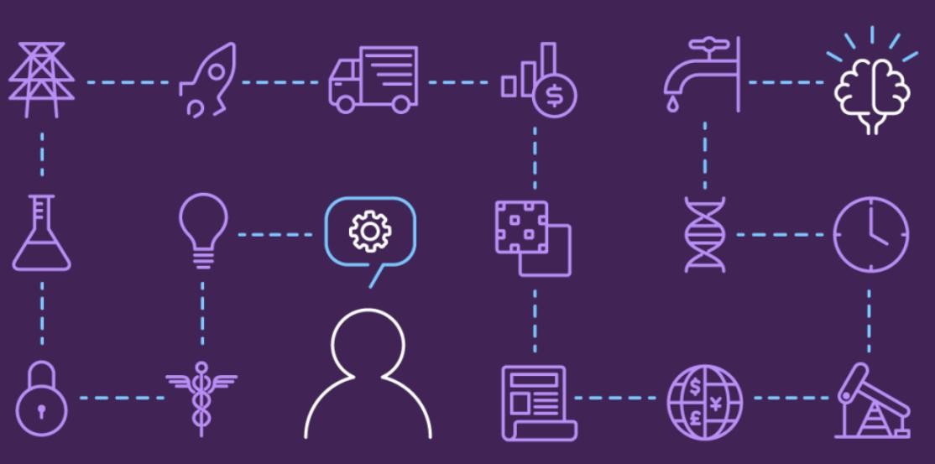

**BATCH MEMBERS:**

**732721205015: Gobika. R**

**732721205017: Gomathi. M**

**732721205020: Hemamalini. S**

**732721205022: Janarthini. S**

**732721205023: Jayasri. S**

Machine Learning Model Deployment with IBM Watson Studio

**Project Overview:**

# Objective:

The objective of this project is to deploy a machine learning model using IBM Cloud Watson Studio, enabling real-time predictions for a specific use case.

# Design Thinking Process:

**Empathize:**

Understand the problem domain and end-user

needs.

Conduct user interviews and gather requirements.

# Define:

Define project scope, objectives, and constraints. Articulate the problem statement and desired outcomes. **Ideate:**

Brainstorm potential solutions and approaches.

Explore different modeling techniques and algorithms.

# Prototype:

Develop a proof-of-concept model to validate the chosen approach.

Test the feasibility of the selected predictive use case.

# Test:

Evaluate the prototype's performance using a validation dataset.

Gather feedback from stakeholders and iterate on the model.

# Develop:

Build the final version of the predictive model.

Integrate it with the IBM Cloud Watson Studio environment.

# Development Phases:

# 

# Phase 1:

Planning and Research

Conduct market research and identify existing solutions.

Define project scope, objectives, and success metrics. Select technologies and tools compatible with IBM Cloud Watson Studio.

# Phase 2:

Data Collection and Preparation

Identify relevant datasets for the selected predictive use case.

Clean, preprocess, and transform the data for model training. Ensure compatibility with IBM Cloud Watson Studio data ingestion methods.

# Phase 3:

Model Training

Choose appropriate algorithms and techniques for the predictive model.

Split the dataset into training, validation, and test sets.

Train the model using IBM Cloud Watson Studio's integrated ML tools.

# Phase 4:

Model Evaluation and Validation

Assess the model's performance using evaluation metrics. Validate the model's predictions against ground truth data. Utilize Watson Studio's visualization tools for analysis.

# Phase 5:

Deployment and Integration with IBM Cloud Watson Studio

Utilize IBM Cloud Watson Studio's deployment capabilities. Integrate the model with the existing system using Watson Studio's deployment and integration features.

# Phase 6:

Testing and Quality Assurance

Conduct thorough testing to ensure the deployed model functions correctly within Watson Studio.

Perform quality assurance checks to identify and address any issues related to the integration**.**

# Use Case Description:

The selected predictive use case is predicting customer churn in a subscription-based service. The model will analyze customer behavior and usage patterns to forecast which customers are likely to cancel their subscriptions.

# Dataset Selection:

**Dataset Description:**

The dataset consists of historical customer data, including features like usage frequency, customer feedback, and demographic information. It also contains a binary target variable indicating whether a customer churned or not.

# Model Training:

**Algorithm Selection:**

Algorithm SelectiFor this customer churn prediction use case, a binary classification algorithm like logistic regression, decision trees, or a neural network will be chosen based on initial prototyping and performance evaluation using IBM Cloud Watson Studio's ML tools.

# Training Process:

The dataset will be split into training, validation, and test sets.

The chosen algorithm will be trained on the training data using Watson Studio's integrated ML capabilities.

Hyperparameters will be fine-tuned using Watson Studio's optimization features.

# Deployment Process with IBM Cloud Watson Studio:

# Model Deployment:

Utilize IBM Cloud Watson Studio to deploy the trained model.

Leverage Watson Studio's deployment capabilities for seamless deployment.

Integration Steps with IBM Cloud Watson Studio:

# System Integration:

Utilize Watson Studio's integration features to seamlessly integrate the model with the existing system.

Leverage IBM Cloud services for secure data transfer and integration.

Accessing and Utilizing the Deployed Model with

# IBM Cloud Watson Studio:

**Real-Time Predictions:**

To access the deployed model, the existing system will send HTTP requests with input data to the Watson Studio deployment endpoint.

# Response Handling:

Watson Studio will process the input data and return predictions (e.g., customer churn probability) as an HTTP response.

# Utilization:

The predictions can be used within the existing system for various purposes, such as prioritizing customer retention efforts or triggering alerts for potential churn.

# Submission:

This project documentation provides a comprehensive record of the objectives, design thinking process, development phases, use case, dataset selection, model training, deployment process with IBM Cloud Watson Studio, integration steps, and instructions for accessing and utilizing the deployed model for real-time predictions.